Name : Alveena naz
Reg no. FA25-BSE-010
OOP lab 5

Task 1:
//main class
import java.util.Date;
public class JavaApplication20
{
public static void main(String[] args) {
Student s = new Student("Alveena","FA25BSE010",12345,"nazalveena@gmail.com","Pass");
s.display();
Date d = new Date();
Faculty f = new Faculty("Ahmed","Fa25bse99",5678,"ahmaed@gmail.com","Room 10",50000,d,23,"Professor");
f.display();
Staff st = new Staff("Ali","fa25bse098",3456,"ali@gamil.com","Admin office",20000,d,"Administrator");
st.display();
}

}
// Person class
public class Person {
String name;
String id;
int phone;
String email;
Person(){}
Person(String n, String id, int p, String email){
this.name = n;
this.id = id;
this.phone = p;
this.email = email;
}
public void display(){
System.out.println("Name "+ name);
System.out.println("ID "+ id);
System.out.println("Phone "+ phone);
System.out.println("Email:" + email);
}
}
//Employee
import java.util.Date;
public class Employee extends Person {
String office;
double salary;
Date dateHired;
Employee(){}
Employee(String n, String id, int p, String email,String office,double salary,Date dh){
super(n,id,p,email);
this.office = office;
this.salary = salary;
this.dateHired = dh;
}
@Override
public void display(){
super.display();
System.out.println("Office: " + office);
System.out.println("Salary: " + salary);
System.out.println("Date hired: " + dateHired);
}

}
//student
public class Student extends Person {
String status;
Student(){}
Student(String n, String id, int p, String email,String status){
this.name = n;
this.id = id;
this.phone = p;
this.email = email;
this.status = status;
}
@Override
public void display(){
super.display();
System.out.println("Status: " + status);
}
}
//faculty
import java.util.Date;
public class Faculty extends Employee{
int hours;
String rank;
Faculty(){}
Faculty(String n, String id, int p, String email,String office,double salary,Date dh,int h,String r){
super(n,id,p,email,office,salary,dh);
this.hours = h;
this.rank = r;
}
@Override
public void display(){
super.display();
System.out.println("Hours: " + hours);
System.out.println("rank: "+ rank);
}
}
//staff

import java.util.Date;

public class Staff extends Employee{
String title;
Staff(){}
Staff(String n, String id, int p, String email,String office,double salary,Date dh,String title){
super(n,id,p,email,office,salary,dh);
this.title=title;
}
public void display(){
super.display();
System.out.println("Title: " + title);
}
}
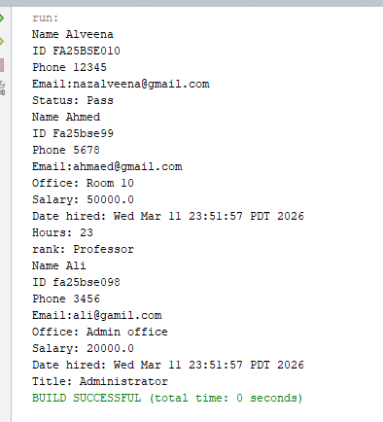

Task 2:
//main
public class JavaApplication21 {
public static void main(String[] args) {
Book b = new Book("PF",2000,456);
b.display();
Tape t = new Tape("OOP",4000,45);
t.display();
}

}
//Publication
public class Publication {
private String title;
private int price;
Publication(){}
Publication(String title,int price){
this.title = title;
this.price = price;
}
public void setTitle(String title){
this.title = title;
}
public void setPrice(int p){
this.price= p;
}
public String getTitle(){
return title;
}
public int getPrice(){
return price;
}
public void display(){
System.out.println("title: "+ title);
System.out.println("Price: " + price);
}
}
// Book
public class Book extends Publication {
private int pageCount;
Book(){}
Book(String title,int price, int count){
super(title,price);
this.pageCount = count;
}
public void setPageCount(int count){
this.pageCount = count;
}
public int getPageCount(){
return pageCount;
}
@Override
public void display(){
super.display();
System.out.println("Pages: " + pageCount);
}
}
//Tape
public class Tape extends Publication{
private int playTime;
Tape(){}
Tape(String title,int price, int playTime){
super(title,price);
this.playTime = playTime;
}
public void setPlayTime(int playTime){
this.playTime = playTime;

}
public int getPlayTime(){
return playTime;
}
@Override
public void display(){
super.display();
System.out.println("Play time: " + playTime);
}

}

OUTPUT:
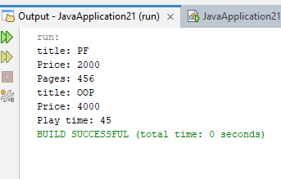

Task 3:
//main
public class JavaApplication22 {
public static void main(String[] args) {
Laptop l = new Laptop(64,8192,512000,3200,35,24,18,15);
l.display();
}

}
//computer
public class Computer {
int wordSize; // in bites
int memorySize; //in megabytes
int storageSize; //megabytes
int speed; //megahurtz
Computer(){}
Computer(int wz,int mz,int sz,int s){
this.wordSize = wz;
this.memorySize = mz;
this.storageSize = sz;
this.speed = s;
}
public void display(){
System.out.println("Word size: " + wordSize);
System.out.println("Memory size: " + memorySize);
System.out.println("Storage size: " + storageSize);
System.out.println("speed : " + speed);

}
}
//Laptop
public class Laptop extends Computer {
int length;
int width;
int height;
int weight;
Laptop(){}
Laptop(int wz,int mz,int sz,int s,int length,int width,int height,int weight){
super(wz,mz,sz,s);
this.length = length;
this.width = width;
this.height = height;
this.weight= weight;

}
@Override
public void display(){
super.display();
System.out.println("Length: " + length);
System.out.println("width: " + width);
System.out.println("Height: " + height);
System.out.println("weight: " + weight);
}
}
OUTPUT:
